**StuFun**

**Mini Project – 2**

**MIDTERM REPORT**



**GLA University, Mathura**

**2020-2021**

**SUBMITTED BY:**

Anubhav Nag (181500109)

Jalanki Nayak (181500291)

Kartik Agrawal (181500311)

Tushar Gupta (181500760)

Yash Vardhan Gautam (181500830)

**SUPERVISED BY:**

Mr. Mandeep Singh (Assistant Professor)

Department of Computer Engineering & Applications

# CONTENT

1. **Abstract**
2. **Introduction** 
   1. General Introduction
   2. Area of Computer Science

## c. Hardware & Software Requirements

1. **Problem Statement**
2. **Objective**
3. **Project Lifecycle**
4. **Implementation Details**
5. **Progress till Date & the remaining work**
6. **Diagrams**
7. **Screenshots**

## ABSTRACT

In this project, we will build a Web application using MERN Stack Technology that will serve both functionalities of a chatting application and an educational application. The inspiration for the chatting application has been taken from WhatsApp Web Functionality as it being the most popular and primary daily chat application on Mobile Phone as well as Desktop. The inspiration for the educational part hasn’t been taken from a single platform but many, primarily being the Google classroom platform and the rest is the QnA section of various online educators such as the likes of Udemy, Coursera, Udacity, etc. The building blocks of the project being ReactJS, NodeJS, ExpressJS, MongoDB (or any other Database like Google Firebase), and the IDE is Visual Studio Code. The Website has two categories of users viz. Teacher and Student. Where a Teacher can create classrooms, add students to it, discuss doubts and give an assignment, a Student can join a classroom, download various resources provided by the teacher, submit his assignments, and can also chat with his fellow students. The choice of MERN Stack as the developing environment is sole because of its wide reach and its ease of use.

## INTRODUCTION

### 1. GENERAL INTRODUCTION

There is numerous active chatting app worldwide, among those WhatsApp scores the highest rank around the globe. WhatsApp was founded by Jan Koum and Brian Acton who had previously spent 20 years combined at Yahoo. WhatsApp joined Facebook in 2014 but continues to operate as a separate app with a laser focus on building a messaging service that works fast and reliably anywhere in the world. As per the record, it serves 2 billion users worldwide. WhatsApp is available in 180 countries and 60 different languages. Due to its many features, it is covering large users. In 2016, WhatsApp also started on Windows and Mac Operating Systems.

It provides us many features to communicate and share pieces of stuff with friends and family easily and cost-efficiently. WhatsApp has many features but Groups in these Chatting Applications are used for informal chats and fun. Using these groups for educational purposes is not preferable and has many limitations. To overcome the limitations discussed above, a Web application needs to be made which can be accessed by anyone who contains the features of both chatting application and classroom. StuFun is a Chatting Web Application which incorporates the features of Classroom which makes it convenient for both fun and educational purpose.

### 2. AREA OF COMPUTER SCIENCE

This project explores the region of Full Stack Web development in the area of Computer Science. The primary tool for developing is MERN Stack i.e. MongoDB – A NoSQL Database used to store, access, and manipulate the data, ExpressJS – A server-side Application Framework that wraps HTTP request and responses, ReactJS – A Frontend JavaScript Framework for building an interactive user interface in HTML, NodeJS – A JavaScript Runtime Environment which executes all the server-side code. We have chosen MERN Stack over other technologies due to its proven results. The IDE for the project in Visual Studio Code and we have used GitHub as our version source control.

As a lot of documentation and designing comes with app development we have used Lucid chart for creating diagrams and graphs and Figma has been used to design the user interface.

**3. HARDWARE AND SOFTWARE REQUIREMENTS**

### Hardware Requirements

* At least 8GB RAM
* Intel i5 g7 processor or equivalent

### Software Requirements

* Visual Studio Code
* NodeJS
* MongoDB (or any other Realtime Database)
* Figma
* Wireframes

## PROBLEM STATEMENT

### INTRODUCTION AND MOTIVATION

Chatting platforms provides us many features to communicate and share pieces of stuff with friends and family easily and cost-efficiently but groups in these Chatting platforms are used for informal chats and fun. Using these groups for educational purposes is not preferable and has many limitations. To overcome the limitations discussed above, an application needs to be made which contains the features of both the chatting application and classroom. StuFun is a Chatting web portal that incorporates the features of the Classroom which makes it convenient for both fun and educational purposes.

On the part of the classroom, the objective is to create a classroom with a chat room/groups-like infrastructure where students can interact with each other and their teachers on matters of their class and studies.

Another major objective of this website on the classroom side is to provide a platform for resource sharing where educational material can be provided to students time by time. As to make the classroom a strong tool for study and making the experience as real as possible we add another objective of creating a question panel in the classroom where it would be compulsory for the teacher to answer questions of the student.

### PROPOSED SOLUTION

Education doesn’t remain aloof from such web platforms; nowadays such groups are also used for educational purposes where teachers create groups of their classes and can share information like class activities, pdf notes, video notes, e-books, etc.

But using these groups for educational purposes has some limitations. There are various cases like –

* Do the websites comply with GDPR guidelines and especially in the case of a student?
* Students can be added only with their mobile numbers which are generally of their parents and they quickly become a pit of unknown digits and faceless profiles.
* Whenever a student is having some doubt regarding a topic and he/she wants to discuss it with the class they share their doubts in the group and a discussion starts which most of the time goes in an informal direction.
* Whenever Teacher wants to provide any information or wants to do any announcement, they post it in the group and a discussion starts which most of the time goes in an informal direction.

## OBJECTIVE

We want to create a Web application using MERN Stack that will function both as a Chatting Application with a professional approach and as a Classroom Application.

## PROJECT LIFECYCLE

* Identifying the problem and writing a problem statement
* Carry out A literature review of the project
* Making an SRS for the project
* In the SRS identifying the major subparts of the app
* Start documenting the major subparts of the app
* Design the various charts and diagrams for the documentation of the major subparts, like the following
* Use case diagrams and their respective ADRs
* Activity diagrams and their respective ADRs
* Class diagrams and their respective ADRs
* Entity-Relationship diagrams and their respective ADRs
* Dataflow diagrams and their respective ADRs
* Construct User Interface prototypes with the help of Wireframes
* Start implementing the design with one subpart at a time, the likes of which are
* Defining, Registering, and Log-in of the two user types viz. Teacher & Student
* Designing the personal chat system for the Student user type
* Designing the classroom chat and resource sharing system for the Teacher user type
* Designing and joining a classroom chat system for the Student user type
* Designing the various subparts of the classroom chat system such as the Assignment panel, the Discussion panel, and the notification panel.
* Testing the various subparts of the project that had been implemented

## IMPLEMENTATION DETAILS

Our Project named StuFun is divided into 4 sections:

### 1. AUTHENTICATION

The authentication section deals with the Registration and Login process into the Application.

It consists of User Selection Panel, Teacher Registration/Login, and Student Registration/Login. For identity verification, email verification would be there before login.

### 2. PERSONAL CHAT

Personal Chat Section has the same functionality as other chatting Applications. Users would be identified by a unique identification ID (Whether phone number or Email Address). Users can chat with each other and can send photos, documents, links via message. All the previous chats would be saved and user can see their previous chats.

### 3. CLASSROOM PANEL (STUDENT)

Classroom panels have different functionalities for teachers and Students. Students can only join the classroom by entering the Class ID generated during creating Classroom. Inside the classroom, Students can view announcements and ask queries inside the discussion panel.

### 4. CLASSROOM PANEL (TEACHER)

The teacher can only create the classroom by entering the details. A unique ID of the class will be generated which will be its identity. Inside the classroom, a teacher can post, delete edit announcements, answer the queries of students, and can monitor the list of students inside the classroom.

Each section will be developed sequentially and the project will be considered to be completed if all 4 sections of the project are successfully developed.

**PROGRESS TILL DATE & REMAINING WORK**

### •PROGRESS TILL DATE

Till now, we have completed our documentation work (Literature Review, SRS, ADR, Wireframes) and 1st section i.e. AUTHENTICATION.

Only the Front-End Portion of the Authentication Panel has been completed.

### • REMAINING WORK

The Front-End Part of the Authentication Panel has been completed. Now we have to complete the Back-End portion of the Authentication Panel and the Front End and Back End portion of the remaining 3 sections i.e., Personal Chat, Classroom panel for Student, Classroom panel for Teacher.

After these remaining sections, the project will be considered completed.

**DIAGRAMS**

1. **USE CASE DIAGRAM**

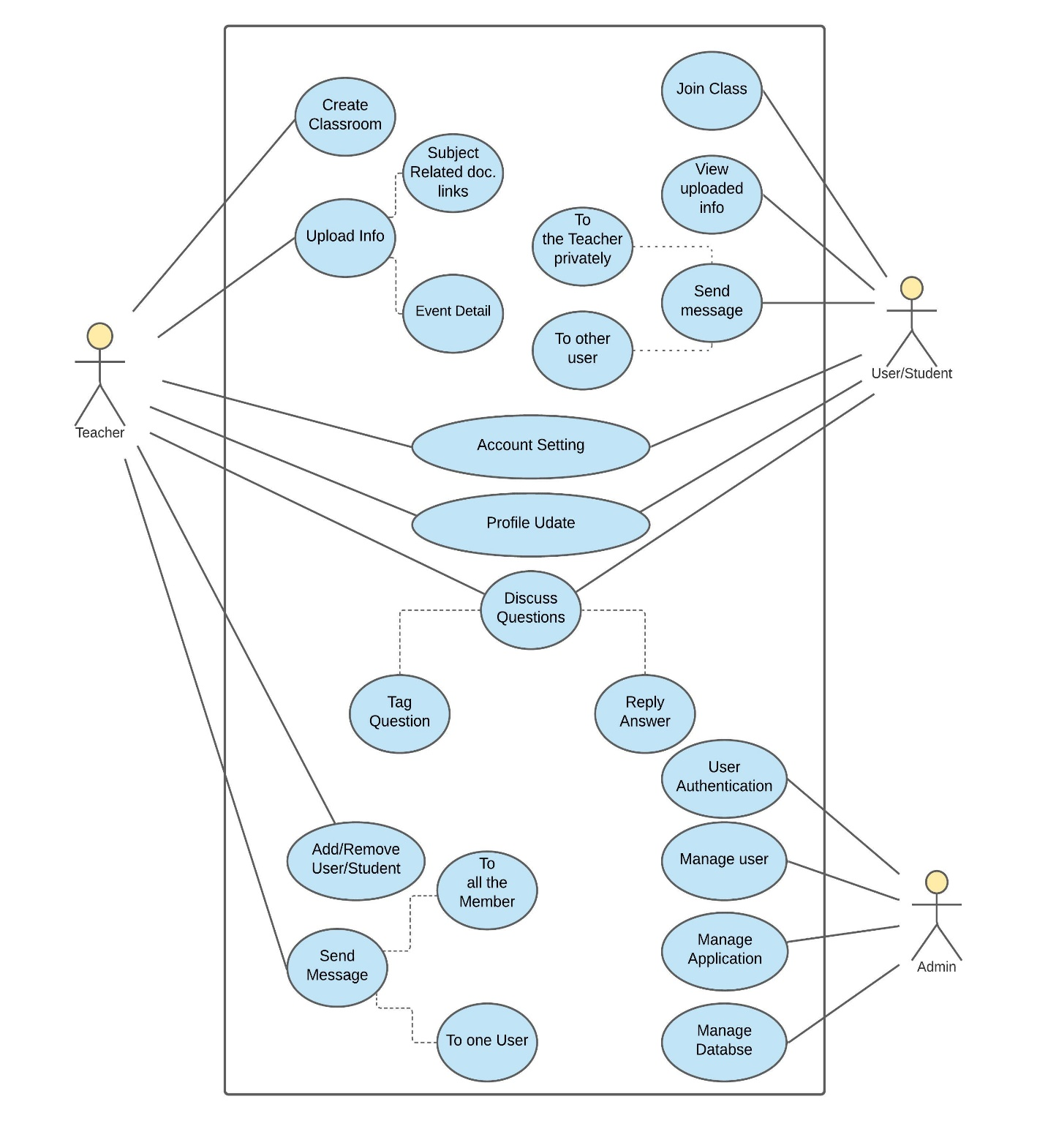

1. **DATA FLOW DIAGRAM**

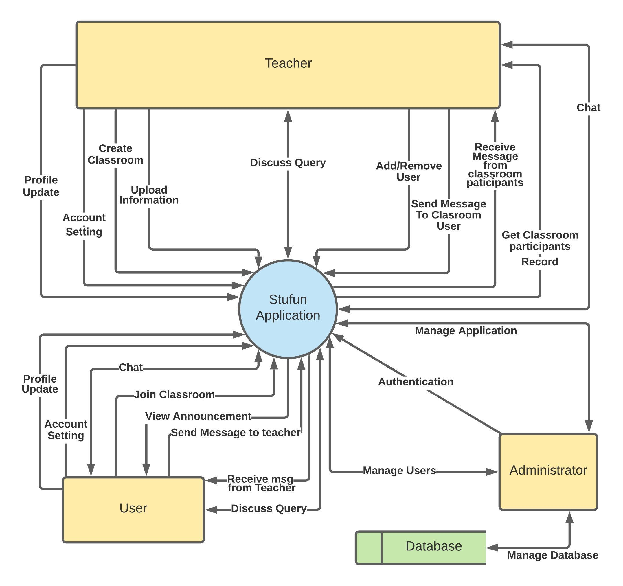

1. **ENTITY RELATIONSHIP DIAGRAM**

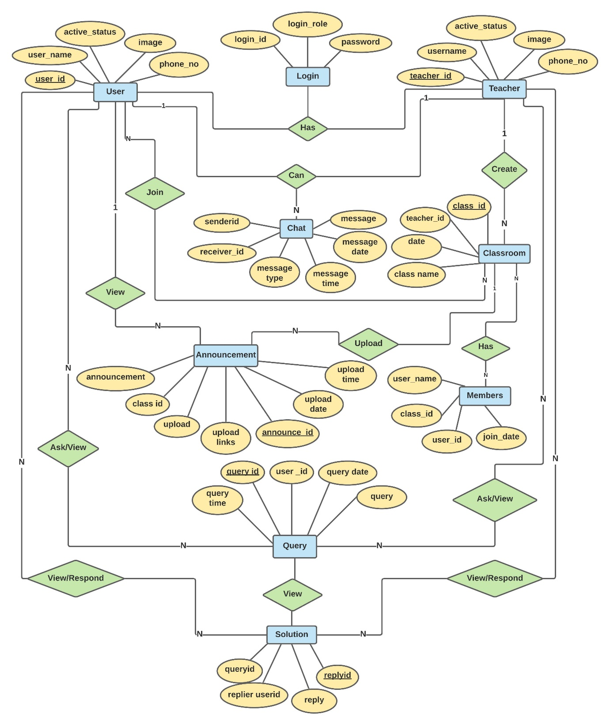

1. **CLASS DIAGRAM**

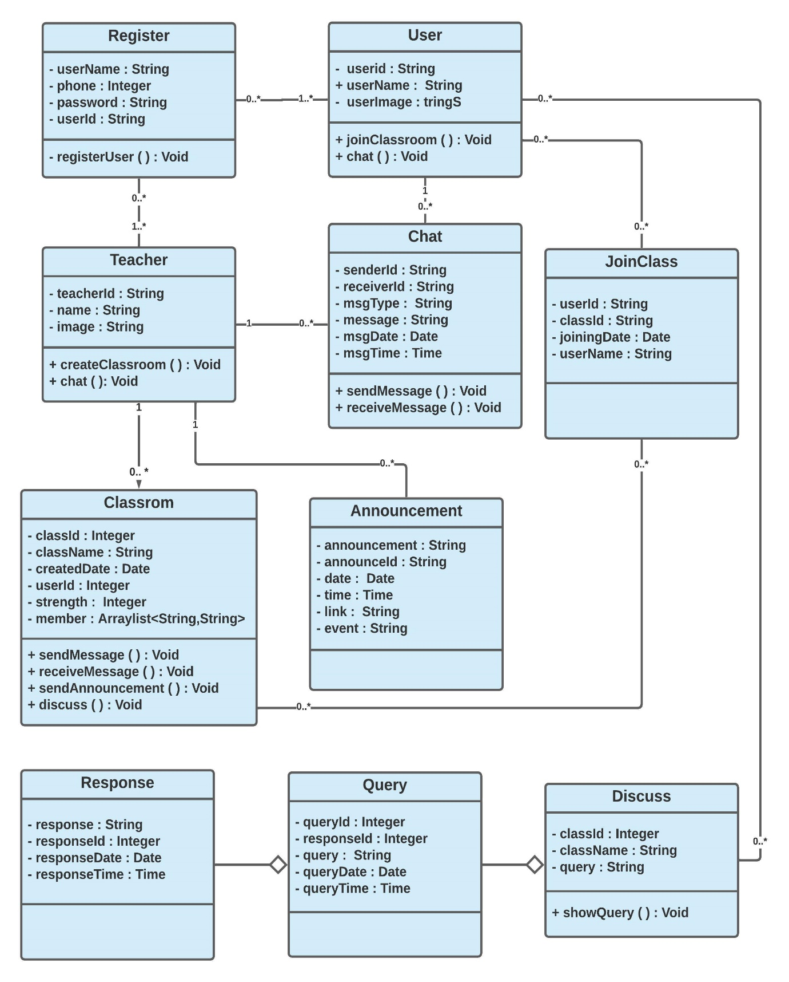

**SCREENSHOTS**

